**Name : Aastha Ahuja  
Date : 10/07/2025  
  
  
  
  
Compressed Path Sum In Zigzag Matrix**

**Problem Statement:**

You are given a square matrix NxN of positive integers. You need to:

1. Traverse the matrix in a zigzag diagonal fashion:

o Start from the top-left element.

o Move diagonally up-right (↗) until you hit the boundary.

o Then move diagonally down-left (↙), and so on, alternating directions until

you reach the bottom-right.

2. At every step, maintain the **running sum** of visited elements.

3. Then, for every **prime number** found in this path, **subtract it from the sum instead of adding it**.

Your task is to return the final computed value.

**Function Signature:**

int compute_zigzag_sum(int** matrix, int n);

**Input:**

• matrix: a 2D dynamic array (allocated properly) of integers, of size n x n

•

n: integer (2 <= n <= 100)

**Output:**

• Return a single integer: the computed zigzag sum as described

S---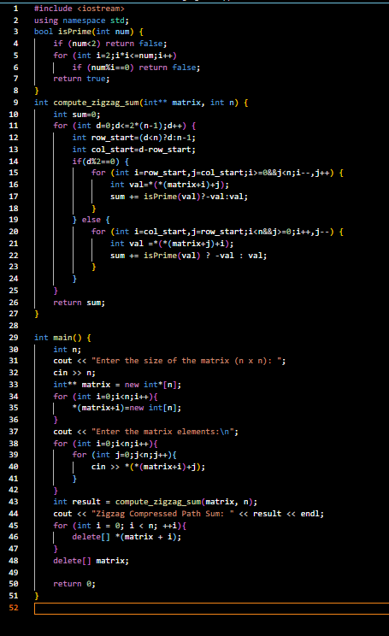

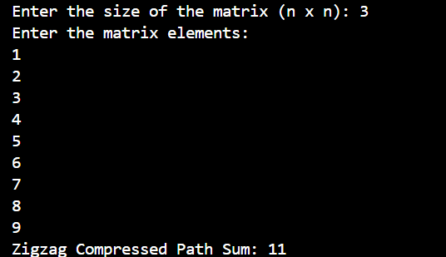  
  
  
  
GitHub Submission Link:  
<https://github.com/Aasthaahuja/Zigzag_Compressed_Sum_Aastha>